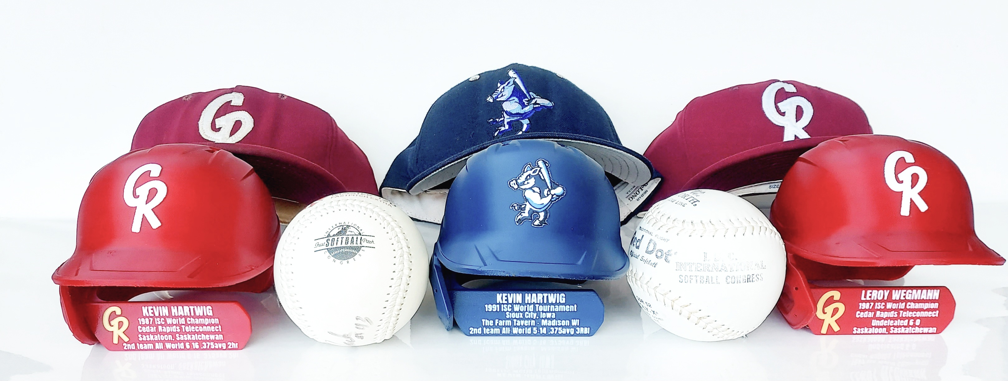

These 3D printed helmets would make great gifts acknowledging:
- Team Achievements
- Player Recognition Achievements
- High Team Finishes in Championship play
- Team Reunions

Text or call Chad Fisher at: 319-329-9753
Instagram: @CPT_30
Email: chadfisher319@gmail.com

Individual helmet cost is $30.00 plus shipping

***NOTE***: The HOF is only providing this as an advertisement for Chad Fisher and is not involved in any financial or operative responsibilities

